MSDS7330

Cipher Squad Members:

Rick Fontenot, Puri Rudick, Joseph Lazarus

6/21/2021

**Project Draft**

**Abstract:**

Bitcoin is the most established cryptocurrency in the market but is still rapidly developing in structure. The original decentralized transaction system now has added second level protocols to facilitate larger volumes of transactions with faster clearing times and lower fees. In this emerging second level transaction marketplace, there are low barriers to entry and opportunities to optimize structure and revenue as a transaction clearing house (node). Our goal is to analyze publicly available data on the market, set up our own node to process transactions, and study methods of optimizing our node structure and fee rates. Beyond the timeline of this initial project and as we collect private data on our node transactions, we aim to build models predicting total revenue as a response to our fee rates and liquidity. The models optimum setup would then be tested on our own node and iteratively updated with new data. Phase 2 of this project could potentially be evaluated as a capstone project.

**What is Bitcoin?**

Bitcoin is a digital cryptocurrency created in 2009. Unlike fiat currency, bitcoin is created, distributed, traded, and stored with the use of a decentralized ledger system, known as a blockchain. It has lower transaction fees than traditional online payments using centralized banks and government issued currencies.

Reference: <https://www.investopedia.com/terms/b/bitcoin.asp>

**How bitcoin is transferred (on-chain vs. off chain)**

Bitcoin uses a blockchain as a ledger to record all transactions. All bitcoin in existence can be found somewhere on the blockchain. All Bitcoin transactions recorded on the blockchain are considered **on-chain transactions** and the ledger is available to the public. Bitcoin is locked in an [address](https://river.com/learn/terms/a/address-bitcoin/), and, using the private key corresponding to that address, you can sign a transaction sending this bitcoin to a new address. All on-chain transactions must pay a transaction fee in order to be included in a block. The higher the fee, the faster the transaction will be confirmed. On-chain transactions are highly secure and reliable, however transaction fees are rising based on demand and the time to confirm and clear a transaction can take 10 minutes to multiple hours. Bitcoin blocks can only hold a certain number of transactions so this method of transaction lacks scalability.

**Off-chain transactions** occur through a private peer-to-peer network where a channel is set up to make many transactions between merchant and/or individual pairs. When the parties have concluded a group of transactions, similar to a tab, the net transfer amount is recorded as a single on-chain transaction and becomes part of the public blockchain ledger. The benefits are lower transaction fees, faster (near instant) confirmation and clearing of transactions and improved scalability for large numbers of transactions. The tradeoffs are higher risk private transactions, capital to meet liquidity requirements, and capacity limits on channels which limit large transactions.

Reference: <https://river.com/learn/on-chain-vs-off-chain-bitcoin-transactions/>

**What is Lightning network?**

The Lightning Network is a second-layer protocol designed to enable off-chain Bitcoin transactions. Because they are not recorded on the blockchain, and thus require no mining, Lightning payments are extremely fast and cheap. Unlike the Bitcoin network, Lightning transactions are not publicly broadcast and instead, individual Lightning nodes transact with one another privately. For example a transaction from party A to party D is not direct and channel is opened Party A 🡪 Node B 🡪 Node C 🡪 Party D. Each node comprising the channel earn a fee for each transaction run through the channel in each direction. When all transactions are complete a single net on-chain transaction is made to the public ledger. The combination of small node transaction fees and the final larger on-chain fee result in a lower fee per transaction and transactions clear much faster.

Reference: <https://river.com/learn/what-is-the-lightning-network/>

**Setting up a node for lightning network**

Anyone can set up and operate a node in the network by setting up software using a local computer or virtual machine. While operating an optimized node can result in fees from income, the potential returns on investment of time and money are small. Currently most node operators are hobbyist with a passion for supporting the network and gaining access to low fee transactions.

After initial lightning node software setup, operators must also set up digital wallets to store and transfer bitcoin, connect their node to network, and optimize fee rates, and build liquidity for their node to be attractive for other parties to use.

See Appendix for our mapping of this setup strategy and current status of implementation.

**Connecting a Node to the network:**

Once a node is initially setup, payments can be made through a channel if the public node key is provided to parties to manually enter into transaction requests. However, to get the general public to choose your node as a channel to deliver the transaction, you need to build connections from your node to others in the network. To do this you must install the bitcoind docker and a local copy of the entire blockchain and synch to the Lightning network. After installation, you need to establish connections with other nodes directly by establishing a channel and funding a transaction.

Since these connections are critical in becoming an attractive channel for other users, choosing the best nodes to connect to first is important to conserve funding. There is an opportunity here to study the most powerful node connections and paths, however with the majority of data being private this is challenging.

See Appendix for our current status of implementation.

Reference: <https://medium.com/coinmonks/the-lightning-network-how-to-install-and-hopefully-make-money-6e3058e3fa7c>

Operating Node and optimizing Lightning network

(fee and liquidity)

<https://blog.bitmex.com/the-lightning-network/>

<https://blog.bitmex.com/the-lightning-network-part-2-routing-fee-economics/>

<https://docs.lightning.engineering/the-lightning-network/liquidity/manage-liquidity>

<https://wiki.ion.radar.tech/tutorials/bootstrapping-liquidity>

**Collecting and analyzing data**

Blockchain (on-network): Using the public on-chain ledger available in a Kaggle database and google cloud’s bigquery tool to perform SQL queries, we will study the on-chain block landscape and trends for fees and blocks handling transactions.

Reference: <https://www.kaggle.com/bigquery/bitcoin-blockchain?select=transactions>

Existing Nodes (off network): Using Node connection maps and node transaction data including liquidity, transaction volume and fees, we will model how to optimize these parameters in our node setup. Note this is primarily private data so sourcing is challenging.

Our Node (off-network): After our lightning node is connected and liquidity is built enough for outside parties to choose our channel, we will collect and analyze our transaction data to study revenue vs. fee rate, connections, liquidity, and transaction volume.

See Appendix for our current status of data collection.

**Optimize Node performance based on modeling data**

Using data referenced above, we will model fee revenue vs. channel connections, liquidity, and fee rates. Then we will adjust setup on our node to study if modeling parameters increase revenue

**APPENDIX**

1. Diagram of Node setup and tools being used

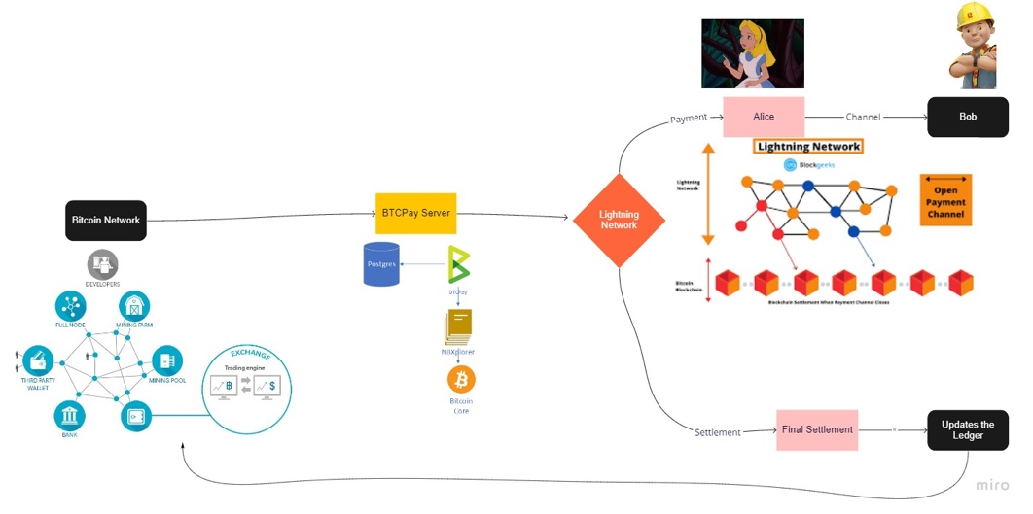

1. Status of Node Setup and Payment Processing:
   1. BTCPayServer was chosen for both operating our node and processing payments. BTCPay is an open-source, self-hosted payment processor for Bitcoin and other cryptocurrencies. BTCPay Server is not a company. To use BTCPay Server, we deployed our own instance in the cloud. Most users are interested in the payment processing feature of BTCPay to integrate into their webpage or online store. This setup is complete and active, however may need more work to access transaction data and possibly need a separate database established prior to data analysis.

If you would like to contribute to our cause, payments can be sent to our public node address: [02b7c1435a910bc8e7e92ae02a9ac06343bb10279fcf68404445476ee611d10c2e@170.75.163.219:9735](mailto:02b7c1435a910bc8e7e92ae02a9ac06343bb10279fcf68404445476ee611d10c2e@170.75.163.219:9735)

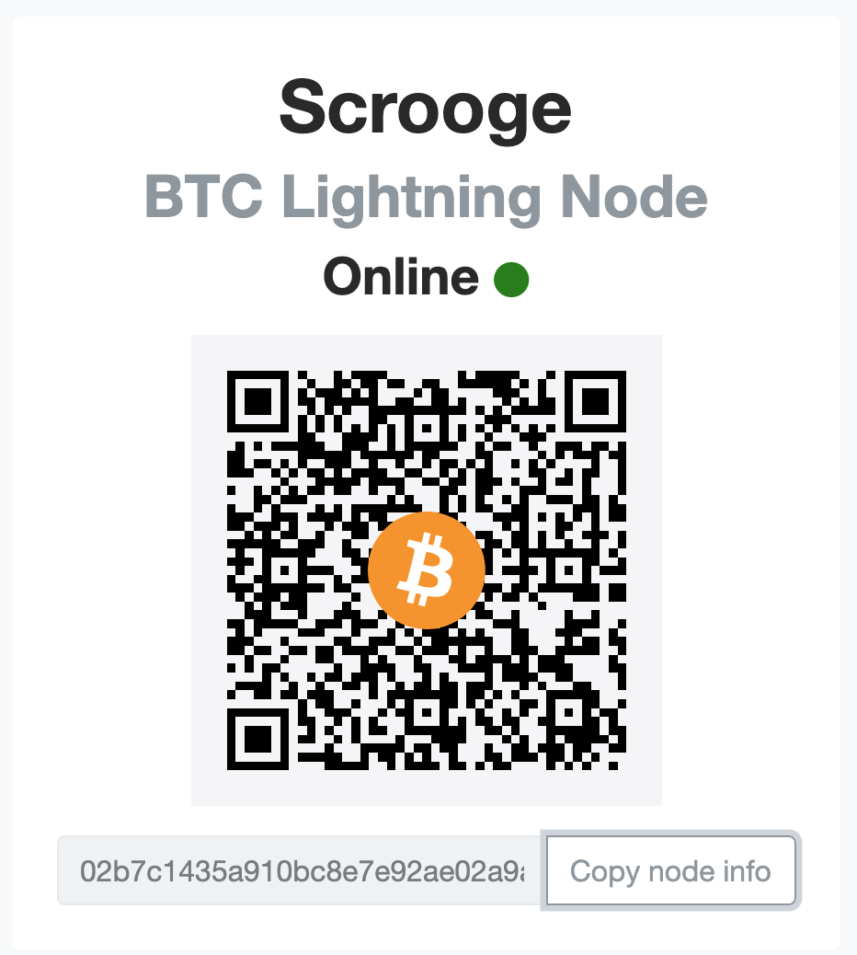

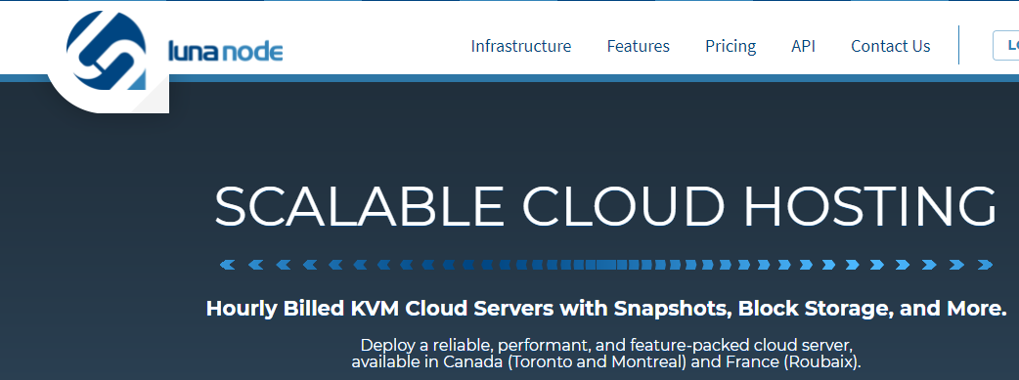

* 1. The developers of BTCPay server teamed up with a web hosting company called Luna Node to provide a user friendly solution to deploying BTCPay. To launch BTCPay server on LunaNode we created an account and API. Our public and private keys are stored safely and the instance is set up.

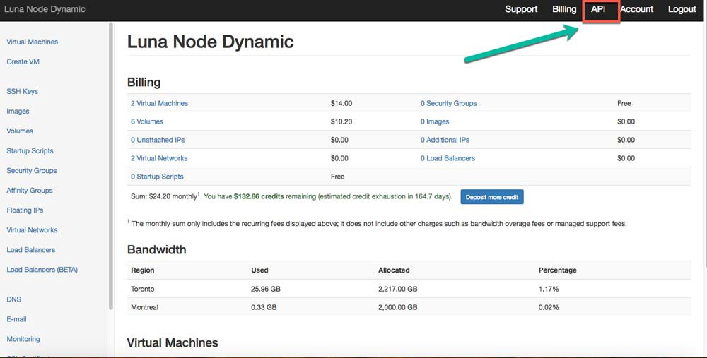

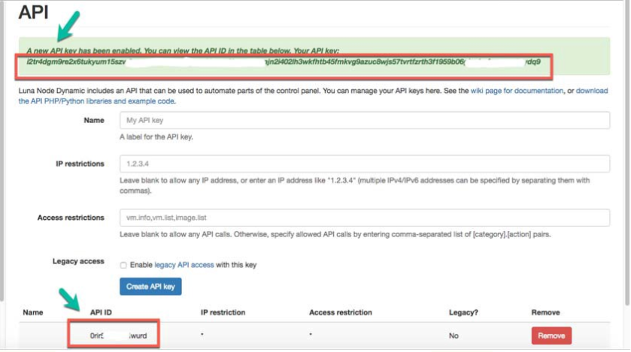

* 1. We have launched the BTCPay server on luna Node and generated our host domain btcpay983737.lndyn.com

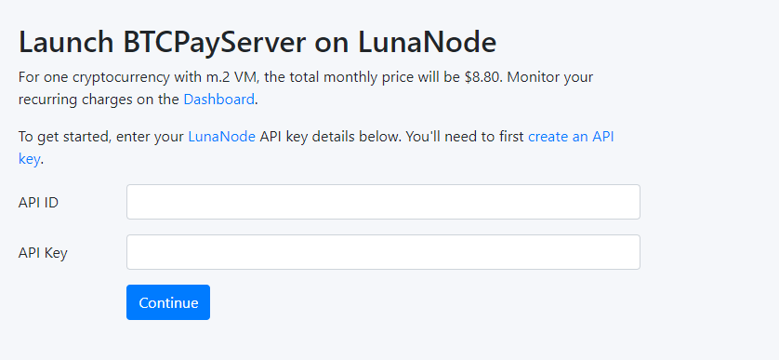

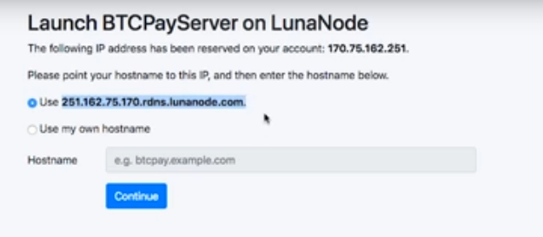

* 1. We provisioned the VM using the BTCpayserver-docker github repository

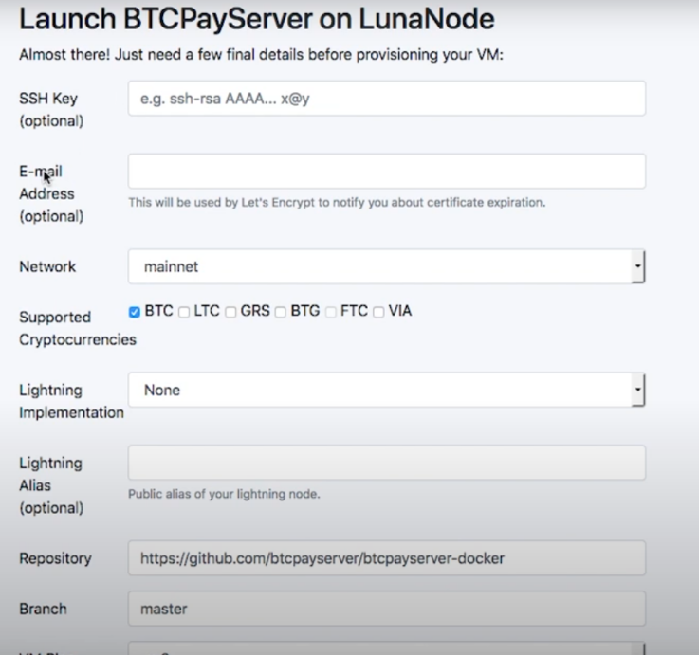

* 1. The node took 3 days to synch with the blockchain network.

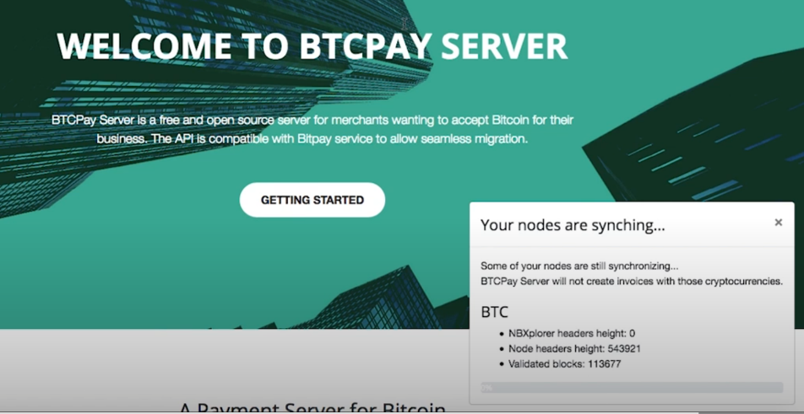

* 1. Accessing Data on the Node: Our BTCPay server stores data in different docker containers. To access these containers we SSH into the server. Once in side we establish root permissions with:

sudo su –

cd btcpayserver-docker

docker exec -ti $(docker ps -a -q -f "name=postgres_1") psql -U postgres

# list databases

\l

# connect to database

\c btcpayservermainnet

# list tables

\dt+

# list users

SELECT "Id", "Email" FROM "AspNetUsers";

# end session

\q

1. Status of Wallet Setup and Initial Transaction:
   1. Zap Wallet was chosen, setup, and we have sent initial payments through our nodes public address.

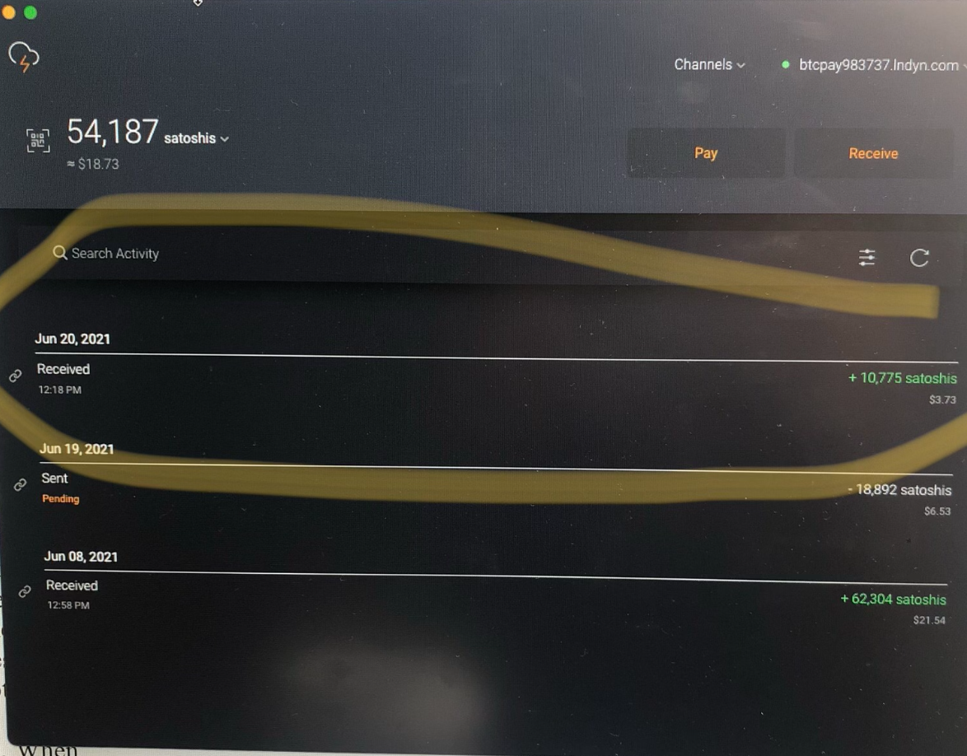

1. Status of Connecting Node to Network:
   1. With initial Zap Wallet payment we established our first connection. However we still need to setup the bitcoind docker and build the number connections which will require capital and may be tough to do rapidly without funding. The funding constraint could limit the amount of significant connections and amount of data we can generate in the timeline of this class project.
2. Status of Data Collection
   1. Blockchain (on-network): Data has been located in a Kaggle database that is updated regularly. Using Google’s bigquery library we have connected and made initial SQL queries through Python to demonstrate feasibility. Due to the size of this big data, we have setup on an AWS Cloud9 instance for remote computing. We are still attempting setup of ipython or jupyter notebooks on the cloud server so that analysis and visualizations are more efficient before proceeding with analysis

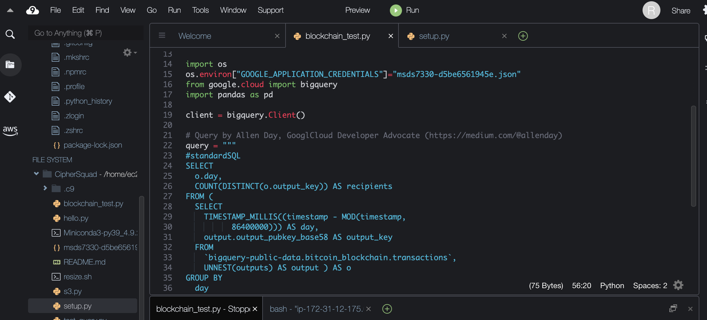

* 1. Existing Nodes (off network): Ideally we’d like to find publicly released data on existing node transactions to look at connections, liquidity, transaction volume and fees so we can model how to set our node rather than attempting trial and error on our node to generate data for analysis. Since these transactions are private, finding a public set has been challenging and we do not have access to one yet at this time.
  2. Our Node (off-network): We do not yet have any data available for our own node yet. Our first private wallet transaction to test is not visible. We are attempting to setup the bitcoind docker and confirm we can access data before spending capital on building connections.